**Investigation of Machining Parameters of Alloy Materials in EDM**

**M.S. Zam1*, L.W. Chin1 & M.M. Rahman2**

1Faculty of Mechanical & Automotive Engineering Technology (FTKMA),

Universiti Malaysia Pahang, 26600 Pekan, Pahang, Malaysia,

2College of Engineering (KKEJ), Universiti Malaysia Pahang,

26600 Pekan, Pahang, Malaysia.

*Corresponding email: zam@ump.edu.my

**ABSTRACT**

Abstract must be one paragraph with about 100 to 250 words. Example of Abstract is here with Introduction, purpose, method, result and conclusion. Proper selection of the machining parameters can result in better machining performance in the electrical discharge machining (EDM) process. This study emphasizes the development of a comprehensive mathematical model for electrode wear rate of a graphite tool in EDM on Ti-5Al-2.5Sn alloy, which is not presented so far. Experiments based on design of experiment for positive polarity of the graphite electrode are conducted first. Modeling and analysis are carried out through the response surface methodology utilizing the experimental results. Confirmation test is also executed to confirm the validity and the accuracy of the developed mathematical model. The confirmation test exhibits the average error is less than 6%. The negative electrode wear is evidenced for particular settings. It is apparent that the developed model can evaluate the electrode wear rate accurately and successfully.

Article History

Received:

09/01/2022

Revised:

29/12/2022

Accepted: 15/02/2022

Published:

07/04/2023

***Keywords:*** Graphite; electrode wear rate; positive polarity; EDM. (5 words max.)

**INTRODUCTION**

Introduction section consists of the literature review for the subject of the study. All statements and claims must be cited with proper references. At the end of the introduction, the purpose of the study must be stated. Example of introduction as follows. In the present study, the material selection was made considering the wide range of applications of titanium alloy (Ti-5Al-2.5Sn) [1, 2] It offers a reduction of aircraft weight [1]. Titanium alloys have enormous uses, yet it accumulates a key problem in machining using conventional techniques [3-5]. One of the crucial difficulties in cutting hard material like titanium alloys is tool wear. In fact, titanium and its alloys are difficult to machine in comparison with steel and aluminum alloys for all conventional machining methods [6, 7]. This is due to a number of inherent properties of titanium alloys. It is recognized that electrical discharge machining (EDM) can be used effectively in machining hard, high-strength, and temperature-resistant materials [4, 8-11]. EDM is also an expertise-demanding process, and the mechanism of metal erosion during sparking is not fully understood due to the complex thermal conduction behaviors in the machining vicinity [12, 13]. Accordingly, it has been hard to establish models that accurately correlate the process variables and the performance.

The parameter settings given by the manufacturers are only applicable to the common steel grades. A single parameter change influences the process in a complex way. Modeling of the process is an effective way of solving the tedious problem of relating the process parameters to the performance measure. Although a number of investigation and studies have been conducted by Kadirgama et al. [3] and Rahman et al. [4], to the best of the knowledge of the authors and according to the literature study, a relationship between electrode wear of the graphite tool and the process variables in the EDM process on Ti-5Al-2.5Sn is still lagging. Then again, one existing model cannot be used for new and dissimilar material and hence experimental investigations are always required. Therefore, this research work concentrates purely on electrode wear of a graphite tool.

The purpose of this study must be stated at the end of introduction section. Example is here: The present paper emphasizes the development of mathematical models for correlating the various machining parameters, namely peak current, pulse-on time, pulse-off time, and servo voltage on one of the most significant criteria electrode wear rate (EWR). As well, it is aimed to determine the values of the selected parameters, which provide the lower tool wear of the graphite electrode during electrical discharge machining on selected titanium material.

**EXPERIMENTAL SET UP**

**Design of Experiment**

The present study aims to associate the correlation between the electrode wear rates of a graphite electrode in EDM process on titanium alloy Ti-5Al-2.5Sn. Response surface methodology was employed throughout the experimental data to build the connection between the wear rate and the process parameters [14] such as peak current, pulse-on time, pulse-off time and servo-voltage. For this reason, the experiment was accomplished according to the design of experiment since design of experiment provides advantages to save time and cost reducing the number of experiments [13, 15, 16]. Here, axial point central composite design was adopted as design of experiment. The four factors as peak current, pulse-on time, pulse-off time and servo voltage are chosen as independent process variables in accordance with the literature consulted, EDM characteristics as well as preliminary experimentations. The effects of the considered parameters were verified through the preliminary experiments. The low and high levels of the process variables are given in Table 1. Hence, total 93 experimental run, including two replications were conducted as main experiments. The mean value of measured electrode wear rate was picked. During experiments, the remaining machining parameters were kept on constant.

Table 1. Process parameters and their levels.

|  |  |  |  |
| --- | --- | --- | --- |
| Designation | Process parameters | Levels | |
|  | Low (-2) | High (+2) |
| *X*1 | Peak Current, *Ip* (A) | 1 | 29 |
| *X*2 | Pulse-on time, *Ton* (µs) | 10 | 350 |
| *X*3 | Pulse-of time, *Toff* (µs) | 60 | 300 |
| *X*4 | Servo voltage, *Sv* (V) | 75 | 115 |

**Experimental Procedure**

The workpiece material is titanium alloy Ti-5Al-2.5Sn with following composition: 0.02% C, 0.15% Fe, 2.6% Sn, 5.1% Al and rest Ti. To develop the relation between various EDM process parameters and electrode wear rate, cylindrical graphite electrode of 20 mm diameter and 50 mm length was used for machining the work sample. Kerosene was selected as a dielectric because of its high flash point, good dielectric strength, transparent characteristics and low viscosity and specific gravity. Each experiment was conducted at fixed supply voltage, 120 V and at a constant dielectric flushing pressure of 0.15 MPa. The experimental set up is shown in Figure 1. A new set of the workpiece and graphite tool were applied for each run. The full sets of run according to the design of experiment were carried out in the state of positive polarity. To evaluate electrode wear rate, the electrode was weighed before and after machining using a digital single pan balance (maximum capacity = 210 gm, precision = 0.1 mg) and are reported in units of gm. Electrode wear rate is calculated by measuring the average amount of electrode eroded and the machining time as Eq. (1):

 (1)

where 

*We* is the weight loss of the electrode in gm,

*W1* is the weight of the electrode before machining in gm,

*W2* is the weight of the electrode after machining in gm

*t* is the machining time in minutes.

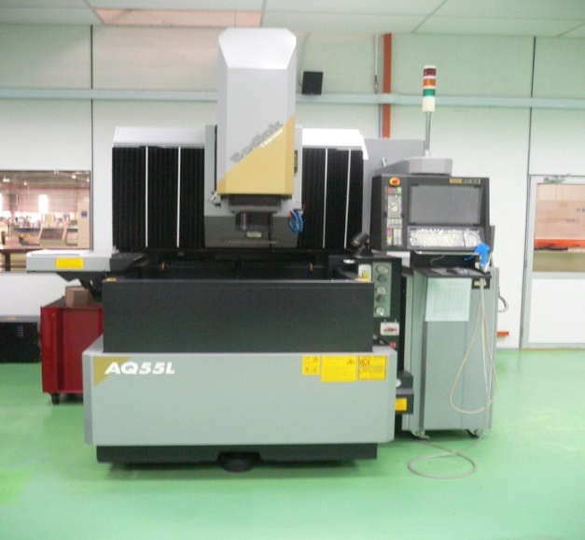 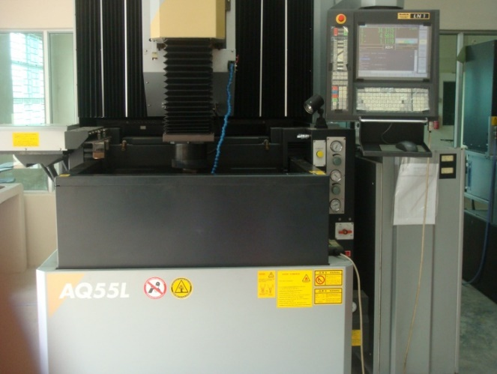

1. (b)

Figure 1. Experimental setup (a) before machining; (b) during machining.

**MATHEMATICAL MODELLING**

Response surface methodology is an assortment of mathematical and statistical techniques that are useful for the modelling and analysis of problems in which a response of interest is biased by several variables and the objective is to optimize this response [11]. It is a sequential experimentation strategy for empirical model building and optimization. A model of the response to some independent input variables can be acquired by carrying out experimentation and applying regression analysis. In RSM, the independent process parameters can be represented in quantitative form as Eq. (2):

*Y* = *f* (*X*1*, X*2*, X*3*, . . . Xn*) ± *ε*  (2)

where, *Y* is the response, *f* is the response function, *ε* is the experimental error, and *X*1, *X*2, *X*3, *. . .*, *Xn* are independent variables.

On the other hand, the second-order model is normally used when the response function is nonlinear. The experimental values are analyzed and the mathematical model is then developed. The mathematical model based on a second-order polynomial is expressed as Eq. (3):

 (3)

where *Y* is the corresponding response, *Xi* is the input variables, *Xi2* and *XiXj* are the squares and interaction terms, respectively, of these input variables. *βo, βi, βij* and *βii* are the unknown regression coefficients.

**RESULTS AND DISCUSSION**

**Statistical Modeling**

Table 2 shows the obtained results using ANOVA. The coefficient of determination is the ratio of the sum of squares of the predicted responses (corrected for the mean) to the sum of squares of the observed responses. The value of *R*2 and adjusted *R*2 is over 99%. This means that mathematical model provides an excellent explanation of the relationship between the independent variables and the response (EWR). The obtained values of standard deviation and *R*2- predicted evidence that the proposed model is adequate to predict the response. The associated *p*-value for the model is lower than 0.05 (i.e. *α* = 0.05, or 95% confidence) indicates that the model is considered to be statistically significant.

Table 2. ANOVA results for electrode wear rate.

|  |  |  |  |  |  |
| --- | --- | --- | --- | --- | --- |
| Source | DOF | Sum of squares | Mean squares | *F*-ratio | *p*-value |
| Regression | 14 | 2.72470 | 0.194621 | 7601.73 | 0.000 |
| Linear | 4 | 1.61069 | 0.402671 | 15727.98 | 0.000 |
| Square | 4 | 0.95657 | 0.239143 | 9340.72 | 0.000 |
| Interaction | 6 | 0.15744 | 0.026240 | 1024.90 | 0.000 |
| Residual error | 16 | 0.00041 | 0.000026 |  |  |
| Lack-of-Fit | 10 | 0.00032 | 0.000032 | 2.08 | 0.191 |
| Pure Error | 6 | 0.00009 | 0.000015 |  |  |
| Total | 30 | 2.72511 |  |  |  |
| Standard deviation (*S*) = 0.00505986 | | | | | |
| *R*2 = 99.98% | | | | | |
| *R*2-adjusted = 99.97% | | | | | |
| *R*2-predicted = 99.93% | | | | | |

When the *p*-value is less than the *α*-level, evidence exists that the model does not accurately fit the data. The p-value for the lack-of-fit is 0.191, which is larger than 0.05 (95% confidence). Hence, the lack-of-fit term is insignificant as it is desired. The fit summary recommended that the quadratic model is statistically significant for analysis of EWR.

**Minimum EWR**

Statistical analysis was performed in order to determine the minimum electrode wear rate. In this study, the negative electrode wear is evidenced for particular settings. The paper reveals that combination of 15 A peak current, 350 µs pulse-on time, 180 µs pulse-off time and 95 V servo-voltage along with positive polarity constructs negative tool wear. Consequently, the maximum negative tool wear rate (-0.4049 mg/min) is found at the combination of *Ip*=16.5 A, *Ton*=350 µs, *Toff* = 60 µs and *Sv* =75 V. It can be explained as part of the molten materials is accumulated on the electrode surface near to the workpiece during machining. This foreign material is attached with the tool surface and protects the tool electrode surface against wear. Further observation can be stated as the more tool wear rate exists in the early stage of machining since the initial surface of the tool was not covered with workpiece material afterword, wear rate decreases.

**CONCLUSIONS**

In this paper, it was attempted to develop a mathematical model that accurately correlates the process variables and machining performance, electrode wear rate of EDM process on Ti-5Al-2.5Sn with graphite electrode. Mathematical model was developed based on response surface methodology utilizing the experimental data. The fitness of the model was verified employing analysis of variance through RSM. In this research, negative tool wear is found at the combination of 15 A peak current, 350 µs pulse-on time, 180 µs pulse-off time and 95 V servo voltage. In addition, the combination of *Ip*=16.5 A, *Ton*=350 µs, *Toff* = 60 µs and *Sv* =75 V yields maximum negative electrode wear rate.

**ACKNOWLEDGEMENTS**

This section is compulsory to appreciate the funding body, research grant and other supporting members. Here is the example: The authors would like to be obliged to Universiti Malaysia Pahang for providing laboratory facilities and financial assistance under the grant no. RDU110110.

**REFERENCES**

[1] K. Taylor, A. Post, T. B. Hoshizaki, and M. D. Gilchrist, “The effect of a novel impact management strategy on maximum principal strain for reconstructions of American football concussive events,” Proc. Inst. Mech. Eng. Part P J. Sport. Eng. Technol., vol. 233, no. 4, pp. 503–513, 2019, doi: 10.1177/1754337119857434.

[2] H. Tan, L. Qin, Z. Jiang, Y. Wu, and B. Ran, “A hybrid deep learning based traffic flow prediction method and its understanding,” Transp. Res. Part C Emerg. Technol., vol. 90, no. January, pp. 166–180, 2018, doi: 10.1016/j.trc.2018.03.001.

[3] J. B. Caccese et al., “Head and neck size and neck strength predict linear and rotational acceleration during purposeful soccer heading,” Sport. Biomech., vol. 17, no. 4, pp. 462–476, 2018, doi: 10.1080/14763141.2017.1360385.

[4] S. L. James et al., “Global, regional, and national incidence, prevalence, and years lived with disability for 354 diseases and injuries for 195 countries and territories, 1990–2017: a systematic analysis for the Global Burden of Disease Study 2017,” Lancet, vol. 392, no. 10159, pp. 1789–1858, 2018, doi: 10.1016/S0140-6736(18)32279-7.

[5] X. Huang, J. Sun, and J. Sun, “A car-following model considering asymmetric driving behavior based on long short-term memory neural networks,” Transp. Res. Part C Emerg. Technol., vol. 95, no. February, pp. 346–362, 2018, doi: 10.1016/j.trc.2018.07.022.