Finite Element Model Updating on Structural Components of Simplified Model of Aircraft Pylon
A R Bahari, M A Yunus^{a)}, M N Abdul Rani, M A S Aziz Shah and W I I Wan Iskandar Mirza
Structural Dynamics Analysis & Validation (SDAV), College of Engineering,
Universiti Teknologi MARA (UiTM), 40450 Shah Alam, Selangor, Malaysia.
^{a)} Corresponding author: mayunus@uitm.edu.my
Abstract. Assumptions and simplifications in finite element (FE) modelling for structural vibration analysis contribute to discrepancies in numerical results. This paper presents FE model updating on components of a simplified model of an aircraft pylon. The components are tested under free-free boundary conditions and roving accelerometers technique is practised in the impact testing. Modal parameters are predicted numerically using NASTRAN SOL 103 normal modes analysis. NASTRAN SOL 200 optimisation for modal based updating method is subsequently used and successfully minimised the total error of the initial FE model from 19.17 per cent to 3.19 per cent. These satisfactory results could be confidently enhanced the quality of the FE model to be used for the further engineering analysis.

Introduction
In aerospace industry, an aircraft consists plenty of structural components and systems [1]. One of the important components is pylon which connects the turbine engine to the airframe of an aircraft [2]. Pylon is exposed to time-varying environmental loading and operational loading conditions [3]. Structural design optimizations and performance analysis on this component are crucial which depend on the precise FE model. The prediction of the dynamic characteristic can only be adequately investigated if the accurate properties of the pylon are considered [4].
The FE model should be able to precisely predict the dynamic characteristic of structures with high confidence [5]. Typically, the prediction by numerical modelling often contributes to some discrepancies due to the uncertainties and assumptions on the structural parameters such as geometry, boundary conditions, material properties and kinematic interactions [6]. FE model updating method is widely used to overcome these discrepancies and alter the FE model to better condition [7], [8]. The modal parameters such as natural frequencies, mode shapes and damping can be measured from experimental modal analysis which enables for assessing the validation of FE model.
In the present work, the nominal material properties of the components of simplified aircraft pylon are extensively updated by using FE model updating. The modal parameters (natural frequencies and mode shapes) are calculated numerically by normal mode analysis. Experimentally measured modal parameters by impact testing are used for model validation.

Experimental modal analysis
The simplified structure of aircraft pylon consists of four components as shown in Figure 1. The components are pylon-to-wing mount, pylon holder, pylon and load store. The structure is made from two types of material, aluminium (pylon-to-wing mount, pylon holder and load store) and stainless steel (pylon).

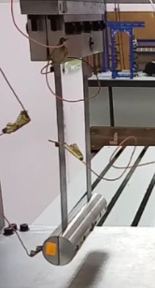
pylon-to-wing mount
pylon
pylon holder
load store
Figure 1. Simplified model of an aircraft pylon

Figure 2 shows the EMA set up applied in this study. Pylon holder and pylon, which are made from different types of material were chosen for the modal analysis and model updating works. Soft springs are used to suspend the pylon holder and pylon on the test rig in order to set the free-free boundary conditions. An impact hammer with a force transducer is used to excite the structure. The applied impulse excitation force was in the broadband of frequency range. LMS SCADAS data acquisition system was used to determine the modal parameters.

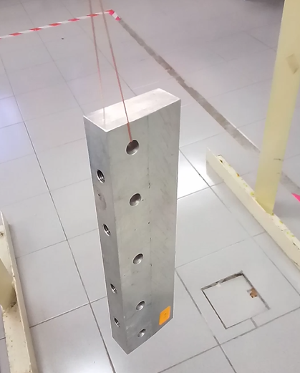 | 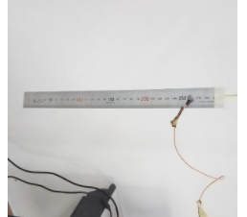
(a) | (b)
Figure 2. Setup of the modal testing for the components of simplified aircraft pylon (a) pylon holder, (b) pylon

Modal testing was performed to determine the natural frequencies and mode shapes of the pylon holder and pylon. Two roving methods were used in this study. The method of roving accelerometer using three lightweight accelerometers for roving and reference was applied in EMA pylon holder. The method of roving hammer using one accelerometer for EMA on pylon. The vibration response was measured with no mass loading issue. The bandwidth for the frequency of interest was 0 to 550 Hz for pylon and 0 to 5500 Hz for pylon holder. LMS Test.Lab analyser was used to process the measured force and vibration responses.

Normal mode analysis
The mid-surface of the 3D CAD model of the pylon in 2D thin shell was discretised and meshed using 1950 CQUAD4 elements. For pylon holder, the 3D CAD model was meshed using 14228 CTETRA elements. Figure 3 shows the FE model of the pylon holder and pylon for numerical modelling and analysis. The nominal material properties are listed in Table 1. Normal modes analysis was performed using Lanczos method to determine natural frequencies and mode shapes in free–free boundary conditions. The bandwidth frequency was in the range of 0-550 Hz for the pylon and 0-5500 Hz for the pylon holder.

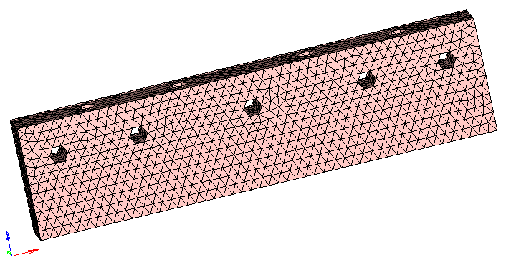
(a)
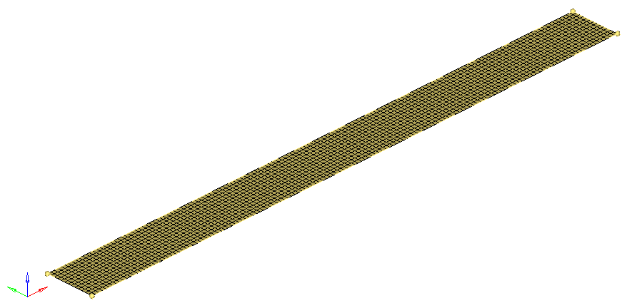
(b)
Figure 3. FE model of the components of simplified pylon (a) pylon holder (b) pylon

TABLE 1. Material properties of the pylon holder and pylon
Properties | Pylon Holder | Pylon
Young’s Modulus (MPa) | 70000 | 190000
Poisson’s Ratio | 0.33 | 0.26
Density (kg/m³) | 2700 | 7870

The global stiffness and mass matrices were extracted based on the geometry and properties of the pylon holder and pylon for the structural dynamic analysis using vibration equation of motion [9], [10]of an undamped FE model using Equation (1)

$$M\ddot{x}+Kx=0$$ | (1)

The structural responses were governed by an eigenvalue equation of Equation (2) where ϕ_{i} is the i^{th} eigenvector or mode shape and λ_{i} is the i^{th} eigenvalue [11], [12].

$$\left(K-λ_{i}M\right)ϕ_{i}=0$$ | (2)

The eigenvalues are associated with the natural frequencies as [13]

$$f_{i}=\frac{λ_{i}}{2π}$$ | (3)

Finite element model updating
The accuracy of modelling the initial FE model is listed in Table 2 and Table 3. The comparison of natural frequencies between EMA and initial FE analysis using nominal material properties has been made. The predicted natural frequencies for the pylon holder are slightly higher compare to the measured natural frequencies with the total error of 13.69 per cent. The error range is between 1.0 per cent and 8.0 per cent. For pylon, the total error is 19.17 per cent with the error range between 1.0 per cent and 5.0 per cent.
In order to minimise the error, NASTRAN optimisation code algorithm (SOL 200) sensitivity-based iterative procedure was used to perform finite element model updating on the initial FE model. The objective function based on eigenvalues was calculated using Equation (4) where is the i^{th} experimental eigenvalue and is the i^{th} predicted eigenvalue from the FE model and n is the number of eigenvalues involved in the updating procedure [14], [15].
$$J=\sum_{i=1}^{n}{W_{i}{\left(\frac{{λ_{i}}^{fe}}{{λ_{i}}^{exp}}-1\right)}^{2}}$$ | (4)

The objective function (J) was minimised by adjusting the eigenvalues of the initial FE model until the objective function was converged. The accuracy of the FE model updating of the pylon holder was evaluated by a comparison between experimental and updated FE analysis as listed in Table 2. The high discrepancies of natural frequencies were decreased to 5.86 percent for the updated FE model. In Table 3, the updated natural frequencies of the pylon were closed to the measured value and the high discrepancies were reduced to lower value from 19.17 per cent to 3.19 per cent.
TABLE 2. Comparison of EMA and updated FE of the pylon holder
Mode |  | EMA  (Hz) | Initial FE Analysis  (Hz) |  | Error (%) |  | Updated FE Analysis  (Hz) |  | Error (%)
1 | 2495.94 |  |  | 2604.63 |  | 4.35 |  | 2491.8 |  | 0.17
2 | 4895.35 |  |  | 5269.49 |  | 7.64 |  | 5040.87 |  | 2.97
3 | 5324.75 |  |  | 5414.92 |  | 1.69 |  | 5179.99 |  | 2.72
 |  |  |  | Total Error |  | 13.69 |  | Total Error |  | 5.86

TABLE 3. Comparison of EMA and updated FE of the pylon
Mode |  | EMA  (Hz) | Initial FE Analysis  (Hz) |  | Error (%) |  | Updated FE Analysis  (Hz) |  | Error (%)
1 | 58.57 |  |  | 56.13 |  | 4.17 |  | 58.66 |  | 0.15
2 | 162.23 |  |  | 154.85 |  | 4.55 |  | 161.84 |  | 0.24
3 | 317.99 |  |  | 303.92 |  | 4.42 |  | 317.7 |  | 0.09
4 | 405.71 |  |  | 400.88 |  | 1.19 |  | 414.65 |  | 2.20
5 | 528.69 |  |  | 503.12 |  | 4.84 |  | 526.03 |  | 0.50
 |  |  |  | Total Error |  | 19.17 |  | Total Error |  | 3.19

The sensitive parameters of the FE models were identified from the computation of sensitivity analysis (SOL 200). Table 4 lists the updated values of the parameters of the pylon holder. A decrement on the updated value was obtained on Young’s modulus from 70000 MPa to 66900 MPa, and the density increased from 2700 kg/m³ to 2798 kg/m³. For pylon, Young’s modulus was increased from 190000 MPa to 198300 MPa. The density was decreased from 7870 kg/m³ to 7520 kg/m³.

TABLE 4. Updated values of the parameters of the pylon holder
Parameters | Initial Value | Updated Value | Unit
Young’s modulus | 70000 | 66900 | MPa
Density | 2700 | 2798 | kg/m³

TABLE 5. Updated values of the parameters of the pylon
Parameters | Initial Value | Updated Value | Unit
Young’s modulus | 190000 | 198300 | MPa
Density | 7870 | 7520 | kg/m³

Figure 4 and Figure 5 show the EMA and FE mode shapes of the pylon holder and pylon. These mode shapes correspond to each natural frequency of bending and torsional modes. The level of correlation between EMA and FE mode shapes was evaluated by the determination of modal assurance criterion (MAC) pairing each mode correctly and calculated using Equation (5) where experimental (ϕ_{m}) and finite element (ϕ_{a}) mode shapes are in matrix form [14], [16]. Well-correlated modes were obtained where the MAC values of pylon holder and pylon were above 0.8.

$$MAC=\left(ϕ_{m}ϕ_{a}\right)=\frac{{\left|{ϕ_{m}}^{T}ϕ_{a}\right|}^{2}}{\left({ϕ_{a}}^{T}ϕ_{a}\right)\left({ϕ_{m}}^{T}ϕ_{m}\right)}$$ | (5)

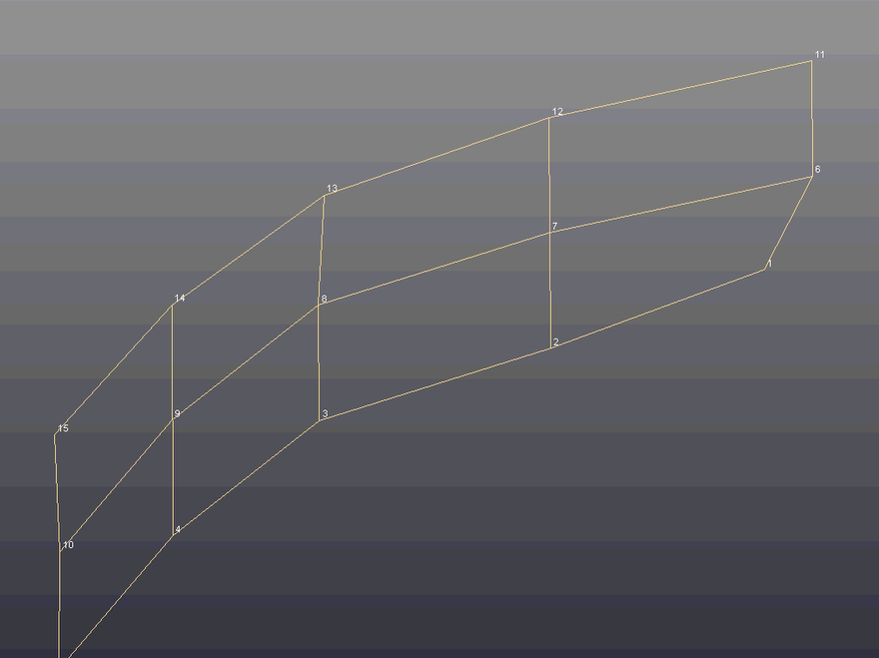 | 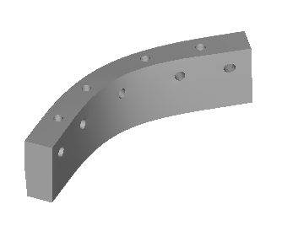
Mode 1 EMA | Mode 1 FE
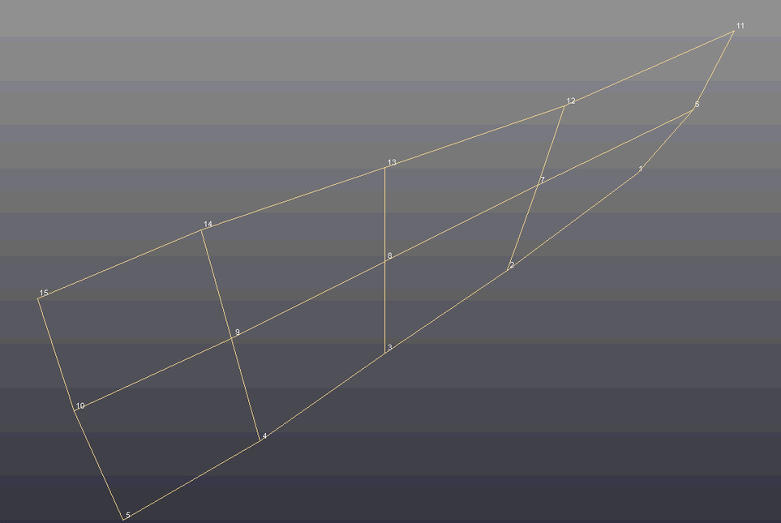 | 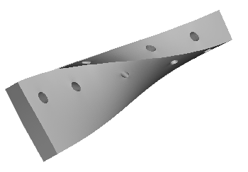
Mode 2 EMA | Mode 2 FE
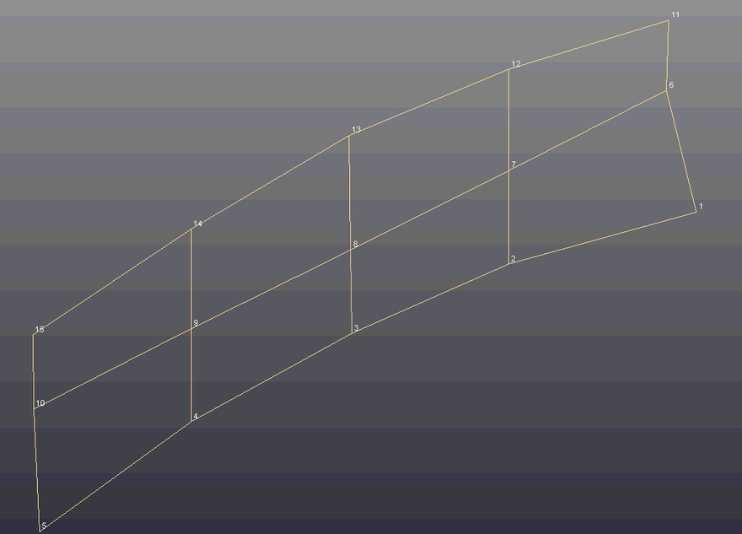 | 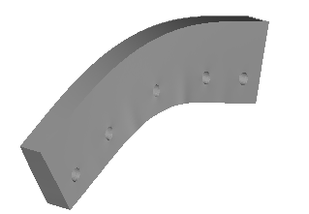
Mode 3 EMA | Mode 3 FE
Figure 4. Comparison of the mode shapes of the pylon holder between the measured and predicted natural frequencies

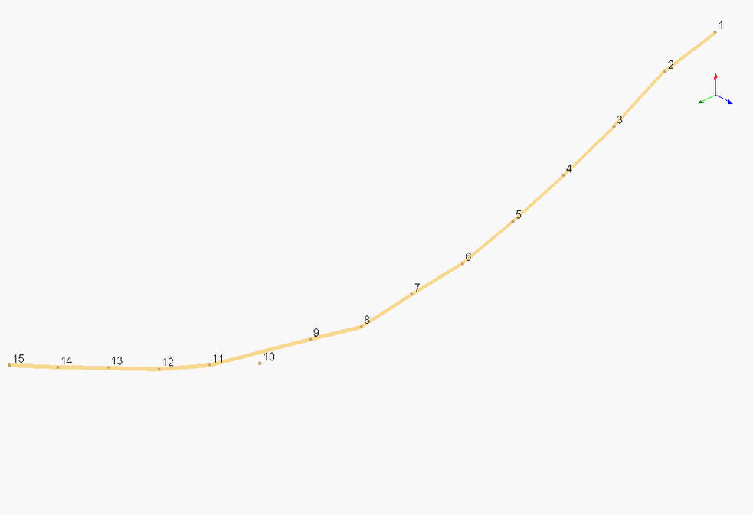 | 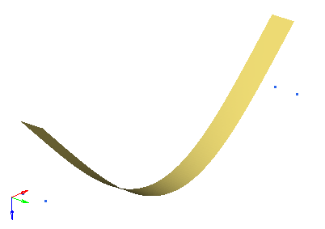
Mode 1 EMA | Mode 1 FE
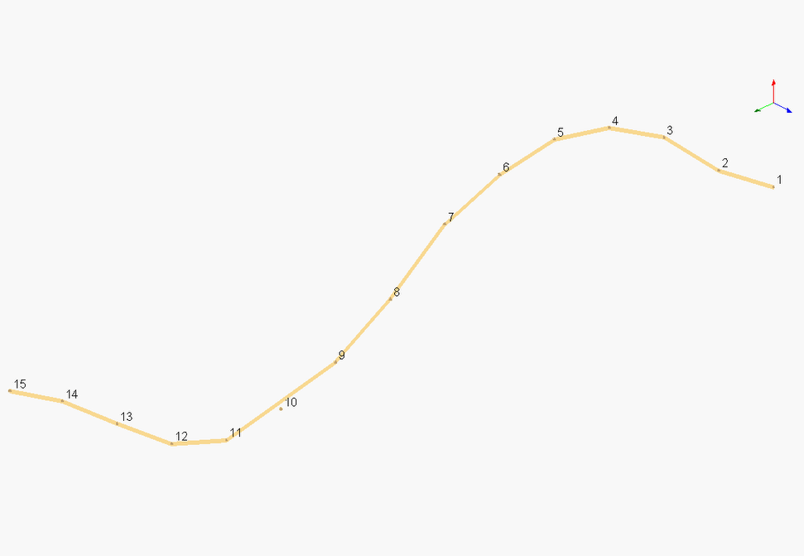 | 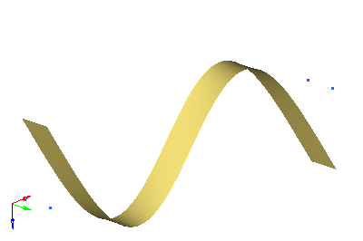
Mode 2 EMA | Mode 2 FE
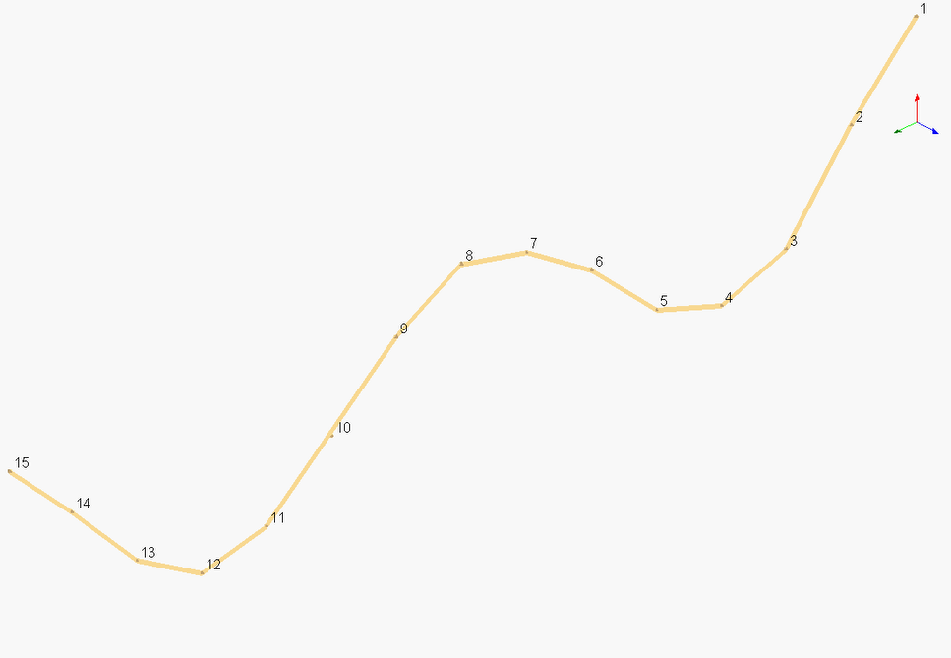 | 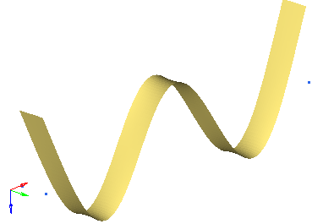
Mode 3 EMA | Mode 3 FE
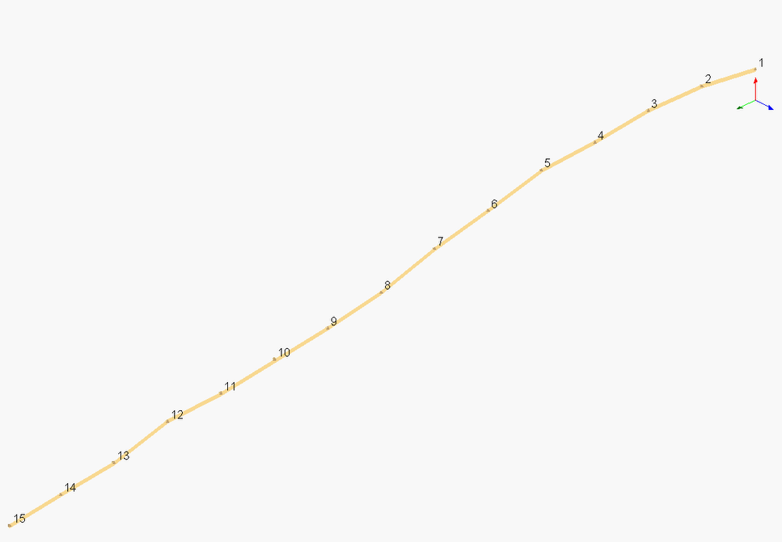 | 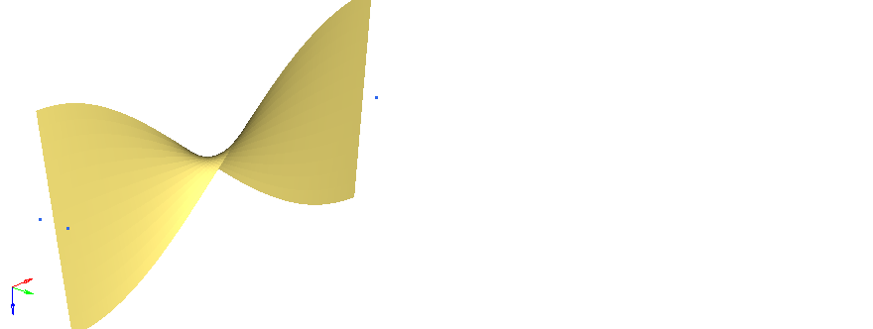
Mode 4 EMA | Mode 4 FE
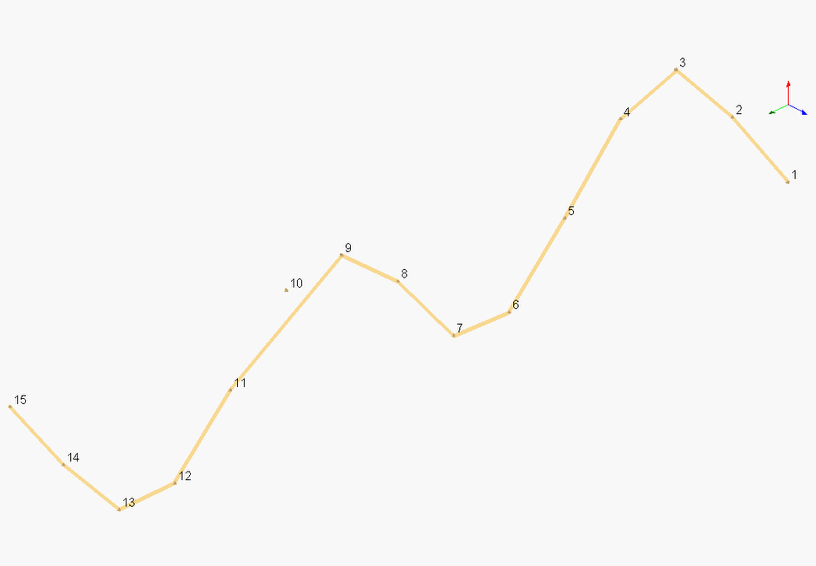 | 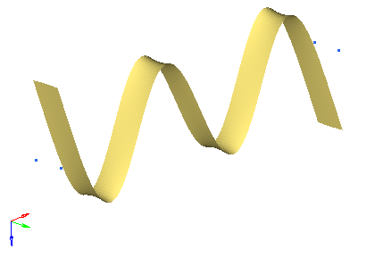
Mode 5 EMA | Mode 5 FE
Figure 5. Comparison of the mode shapes of the pylon between the measured and predicted natural frequencies

CONCLUSION
The nominal material properties of the simplified aircraft pylon (components of pylon holder and pylon) have been updated successfully. The natural frequencies and mode shapes of each component have been obtained numerically using NASTRAN SOL 103 normal mode analysis and measured experimentally using modal testing under lightly damped free-free boundary conditions. Sensitivity analysis via NASTRAN SOL 200 and FE model updating have been performed and updated Young’s modulus and density. The total error of the initial FE model of the pylon holder has been reduced from 13.69 per cent to 5.86 percent. The large discrepancy of the FE model of the pylon has been improved to a low error of 3.19 percent. Thus, further analysis on the dynamic characteristic of this simplified aircraft pylon can be simulated using these validated FE models.

Acknowledgments
The authors acknowledge Universiti Teknologi MARA and Malaysian Ministry of Higher Education for the financial support of Fundamental Research Grant Scheme 600-IRMI/FRGS 5/3/ (465/2019).

References
[1] H. G. Kim and S. C. Kim, “Development of equivalent model of external fuel tank assembly for dynamic characteristics analysis of aircraft,” Aerosp. Sci. Technol., vol. 111, p. 106547, 2021.
[2] C. Ligeikis, A. Bouma, J. Shim, S. Manzato, R. J. Kuether, and D. R. Roettgen, “Modeling and experimental validation of a pylon subassembly mockup with multiple nonlinearities,” Conf. Proc. Soc. Exp. Mech. Ser., vol. 1, pp. 59–74, 2021.
[3] Y. Xu, D. Cao, H. Lin, and C. Shao, “An alternative simulation approach for the ONERA aerodynamic model and its application in the nonlinear aeroelastic analysis of slender wings with pylon-store system,” Int. J. Non. Linear. Mech., vol. 105, pp. 55–76, 2018.
[4] R. Astroza, H. Ebrahimian, and J. P. Conte, “Performance comparison of Kalman - based filters for nonlinear structural finite element model updating,” J. Sound Vib., vol. 438, pp. 520–542, 2019.
[5] P. Górski, M. Napieraj, and E. Konopka, “Variability evaluation of dynamic characteristics of highway steel bridge based on daily traffic-induced vibrations,” Meas. J. Int. Meas. Confed., vol. 164, pp. 1–20, 2020.
[6] A. R. Bahari, M. A. Yunus, M. N. Abdul Rani, W. I. I. W. I. Mirza, M. A. S. Aziz Shah, and Z. Yahya, “Finite Element Modelling and Updating of a Thin Plate Structure using Normal Mode Analysis,” IOP Conf. Ser. Mater. Sci. Eng., vol. 1062, no. 1, 2021.
[7] J. W. R. Meggitt and A. T. Moorhouse, “Finite element model updating using in-situ experimental data,” J. Sound Vib., vol. 489, p. 115675, 2020.
[8] M. A. Yunus, H. Ouyang, M. A. Rani, and A. M. Isa, “Finite element modelling and updating of bolted joints in a thin sheet metal structure,” in 20th International Congress on Sound and Vibration, 2013, pp. 1146–1152.
[9] L. Dai and R. Xiao, “Optimal design and analysis of deployable antenna truss structure based on dynamic characteristics restraints,” Aerosp. Sci. Technol., vol. 106, p. 106086, 2020.
[10] A. R. Bahari, M. A. Yunus, M. N. Abdul Rani, W. I. I. Wan Iskandar Mirza, and A. R. Haizuan, “A comparative study of the vibrational effects on the boundary conditions of a slender beam,” in AIP Conference Proceedings, 2019, vol. 2059, no. 020054, pp. 1–9.
[11] D. Richiedei, I. Tamellin, and A. Trevisani, “A homotopy transformation method for interval-based model updating of uncertain vibrating systems,” Mech. Mach. Theory, vol. 160, p. 104288, 2021.
[12] M. Girardi, C. Padovani, D. Pellegrini, and L. Robol, “A finite element model updating method based on global optimization,” Mech. Syst. Signal Process., vol. 152, p. 107372, 2021.
[13] R. Omar et al., “Investigation of mesh size effect on dynamic behaviour of an assembled structure with bolted joints using finite element method,” Int. J. Automot. Mech. Eng., vol. 15, no. 3, pp. 5695–5708, 2018.
[14] J. Naranjo-Pérez, M. Infantes, J. Fernando Jiménez-Alonso, and A. Sáez, “A collaborative machine learning-optimization algorithm to improve the finite element model updating of civil engineering structures,” Eng. Struct., vol. 225, no. September, 2020.
[15] M. A. S. A. Shah, M. A. Yunus, A. M. Saman, M. N. A. Rani, A. R. Bahari, and C. Peter, “Finite Element Model Updating of Laser Stitch Welded Structure,” in IOP Conference Series: Materials Science and Engineering, 2019, vol. 506, no. 1.
[16] A. R. Bahari, M. A. Yunus, M. N. Abdul Rani, A. Nalisa, and M. A. S. A. Shah, “Investigation on the effects of suspension stiffness using experimental modal analysis and finite element model updating,” in IOP Conference Series: Materials Science and Engineering, 2019, vol. 506, no. 1.

